The Liz Hogan Agency in your community |  | “Quotes for a Cause” Helping   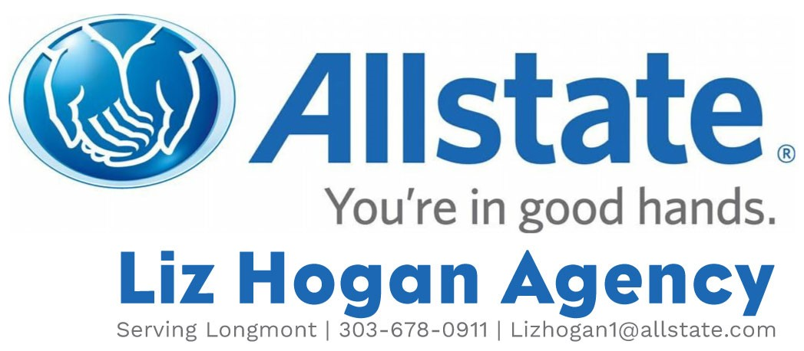  Call Today for a Quote!!!  303-678-0911  939 Coffman St Longmont, CO, 80501  For mentioning Habitat Classes you will get a $20 gift card and our Agency will donate $20 to Habitat for Humanity of the St Vrain Valley

